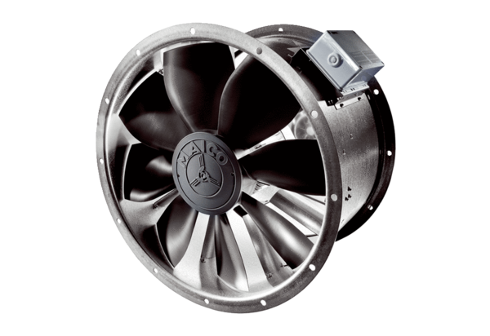Axial duct fan DZL 30/2 BPacking unit: 1 pieceRange: C
Article number: 0086.0081Manufacturer: MAICO

