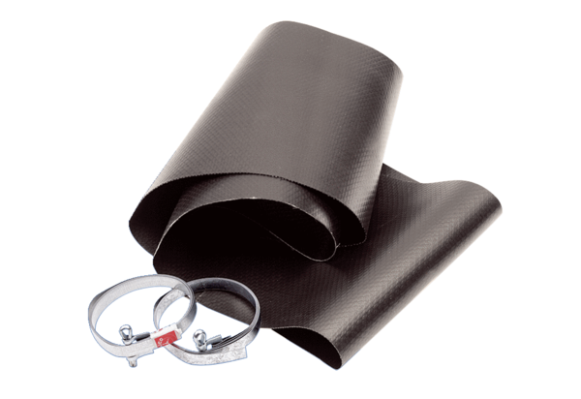Flexible cuff EL 50Packing unit: 1 pieceRange: C
Article number: 0092.0092Manufacturer: MAICO

