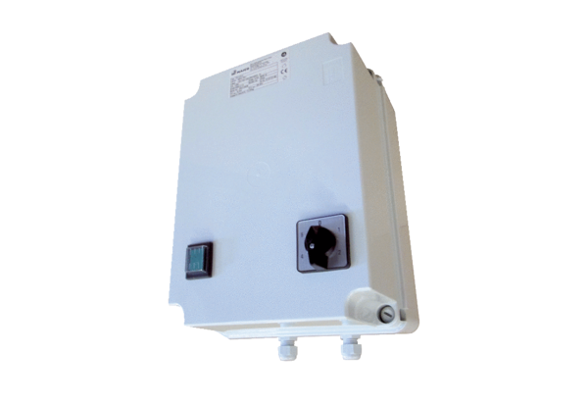5-step transformer TR 0,4-2Packing unit: 1 pieceRange: C
Article number: 0157.0147Manufacturer: MAICO

