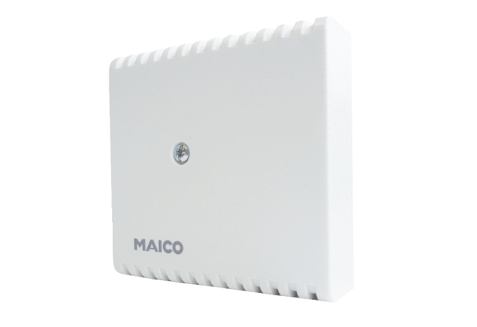Hygrostat HY 230 IPacking unit: 1 pieceRange: C
Article number: 0157.0127Manufacturer: MAICO

