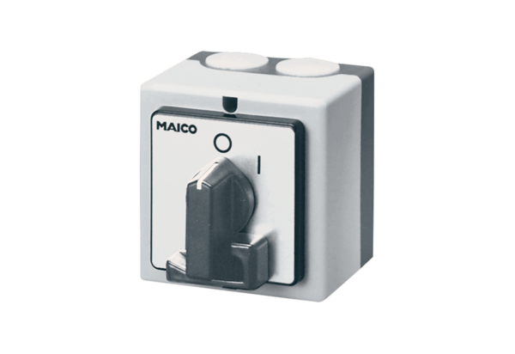Main switch, service switch HS 6Packing unit: 1 pieceRange: C
Article number: 0157.0737Manufacturer: MAICO

