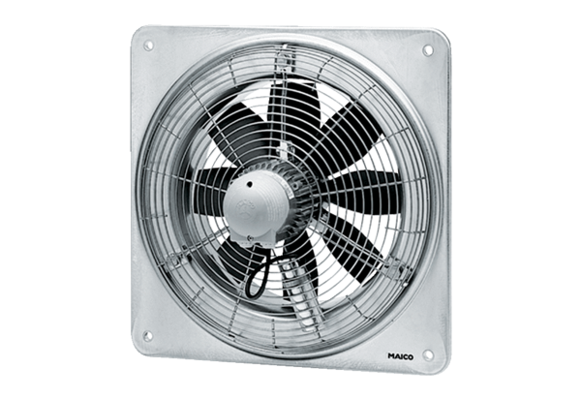Axial wall fan DZQ 30/42 BPacking unit: 1 pieceRange: C
Article number: 0083.0147Manufacturer: MAICO

