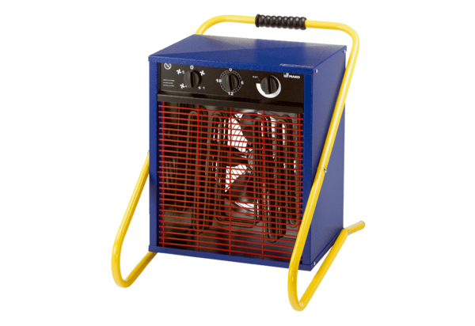Heater fan PHD 15Packing unit: 1 pieceRange: C
Article number: 0082.0068Manufacturer: MAICO

