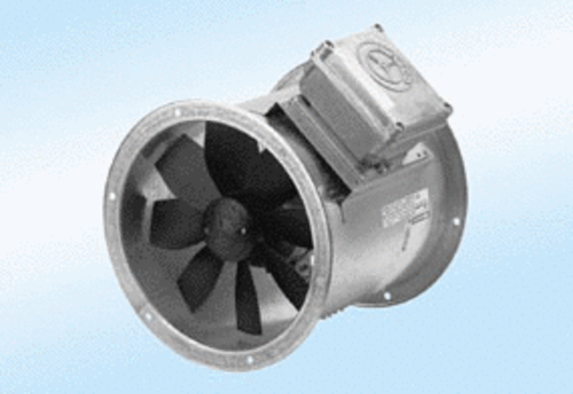Axial duct fan DZR 35/2 A-ExPacking unit: 1 pieceRange: C
Article number: 0086.0772Manufacturer: MAICO

