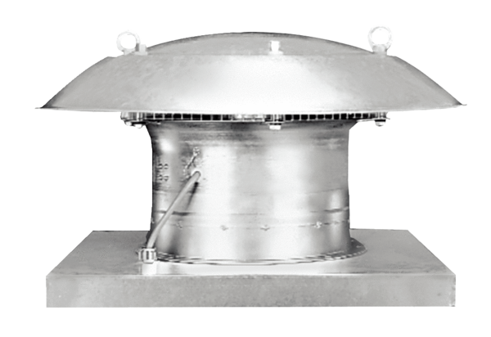Axial roof fan DZD 30/4 BPacking unit: 1 pieceRange: C
Article number: 0087.0215Manufacturer: MAICO

