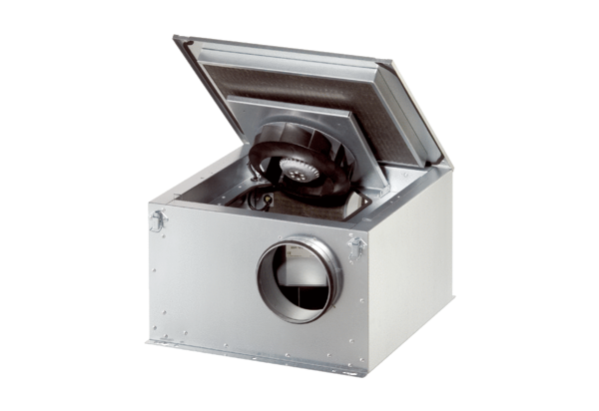Sound-insulated ventilation box ESR 12-2 SPacking unit: 1 pieceRange: C
Article number: 0080.0617Manufacturer: MAICO

