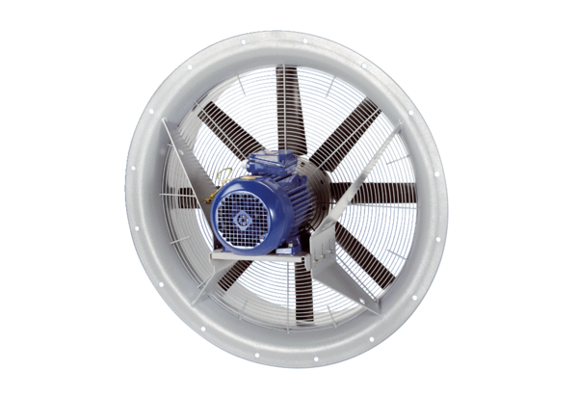Axial fan DAS 71/6Packing unit: 1 pieceRange: C
Article number: 0083.0852Manufacturer: MAICO

