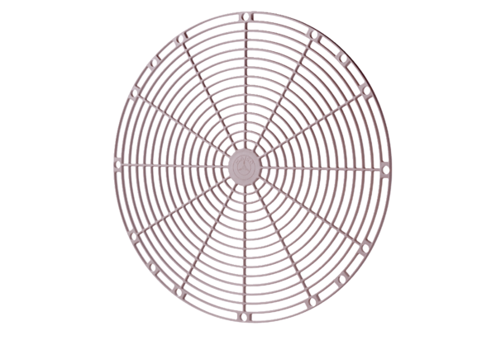Protective grille, synthetic material SGK 25Packing unit: 1 pieceRange: C
Article number: 0059.0162Manufacturer: MAICO

