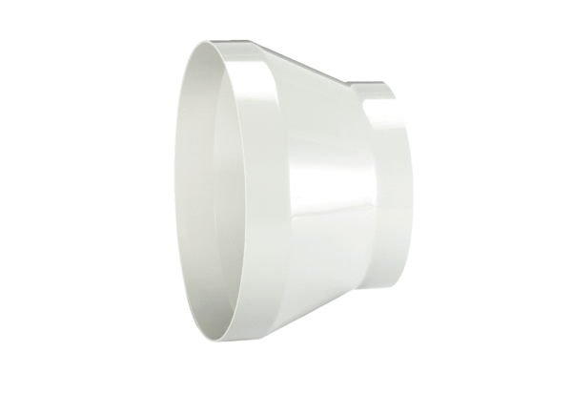Reducer REM 22/18Packing unit: 1 pieceRange: C
Article number: 0059.0634Manufacturer: MAICO

