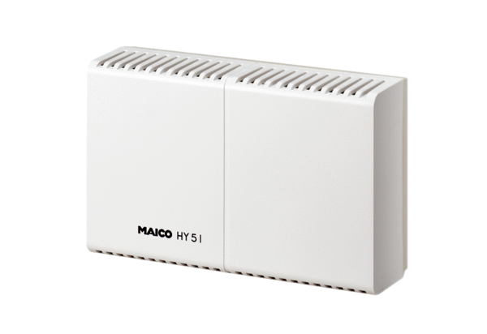Hygrostat HY 5 IPacking unit: 1 pieceRange: C
Article number: 0157.0125Manufacturer: MAICO

