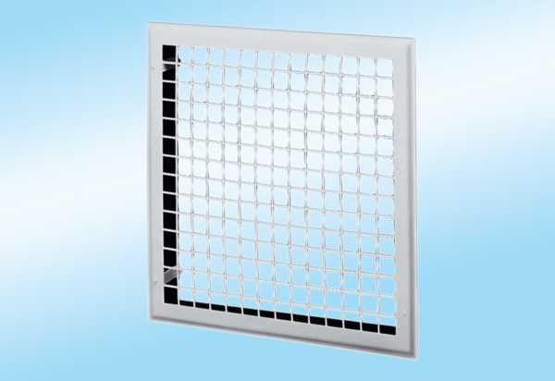Internal grille MLG 35Packing unit: 1 pieceRange: C
Article number: 0151.0064Manufacturer: MAICO

