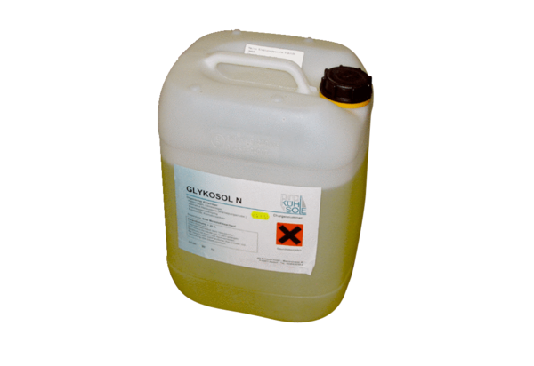Glycosol N EW-GPacking unit: 1 pieceRange: K
Article number: 0331.0011Manufacturer: MAICO

