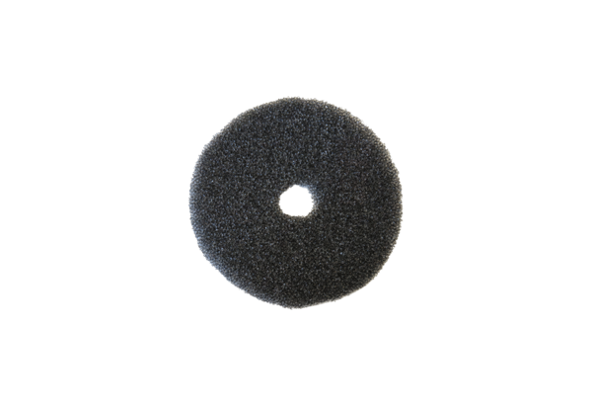Air filter, replacement ZF ECDPacking unit: 2 piecesRange: B
Article number: 0093.1561Manufacturer: MAICO

