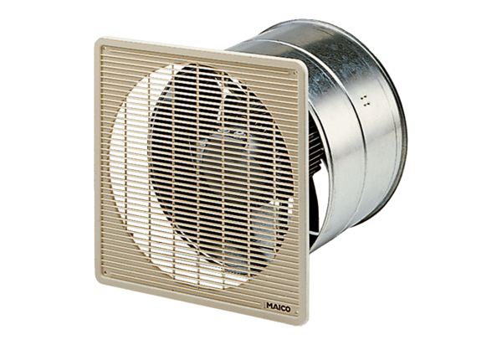EZF 30/4 BPacking unit: 1 pieceRange: C
Article number: 0085.0054Manufacturer: MAICO

