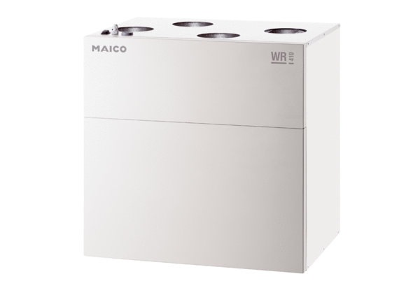Centralised ventilation unit WR 310Packing unit: 1 pieceRange: K
Article number: 0095.0220Manufacturer: MAICO

