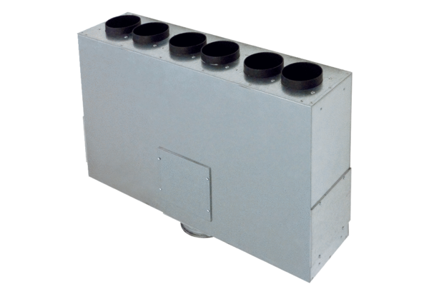Air distributor box made of sheet metal, 6-way MF-BV75-125-6Packing unit: 1 pieceRange: K
Article number: 0018.0527Manufacturer: MAICO

