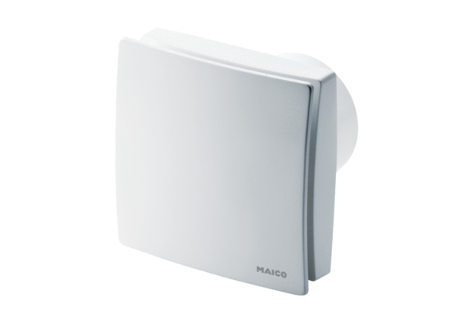Small room fan ECA 150 ipro KHPacking unit: 1 pieceRange: A
Article number: 0084.0095Manufacturer: MAICO

