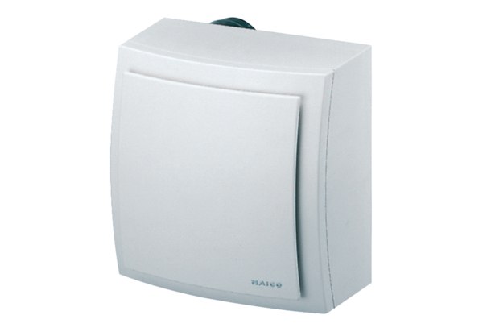Surface-mounted fan ER-AP 100Packing unit: 1 pieceRange: B
Article number: 0084.0170Manufacturer: MAICO

