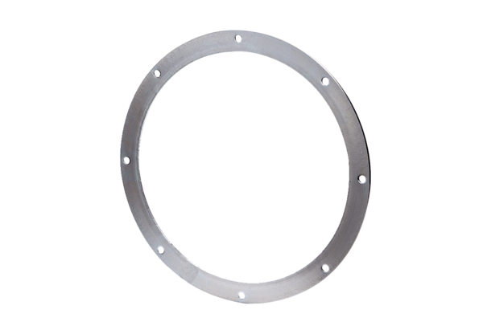Counter flange GF 50Packing unit: 1 pieceRange: C
Article number: 0056.0008Manufacturer: MAICO

