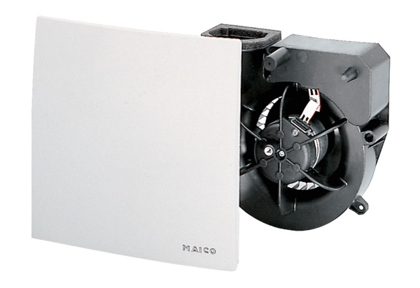Fan insert ER 60 VZCPacking unit: 1 pieceRange: B
Article number: 0084.0106Manufacturer: MAICO

