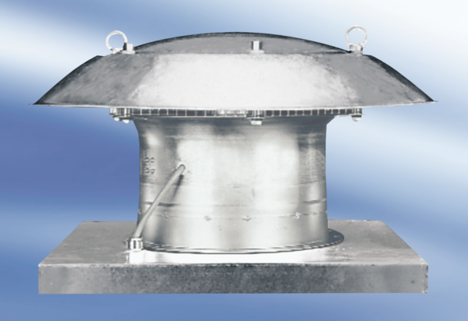Axial roof fan DZD50-4APacking unit: 1 pieceRange:
Article number: 0087.0426Manufacturer: MAICO

