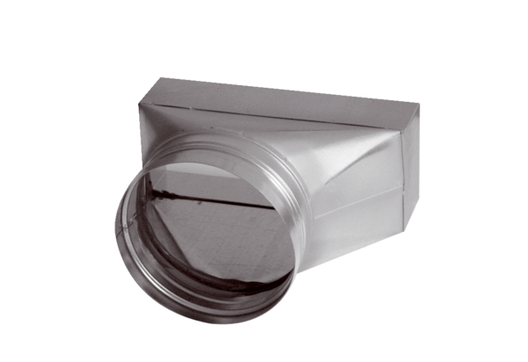Intermediate piece, asymmetric USAN80/200/100Packing unit: 1 pieceRange: K
Article number: 0055.0671Manufacturer: MAICO

