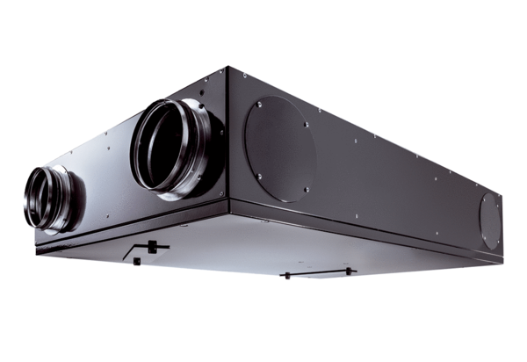Centralised ventilation unit Trio LZVPacking unit: 1 pieceRange: K
Article number: 0095.0125Manufacturer: MAICO

