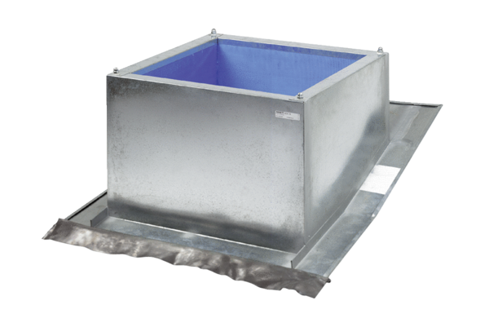Roof socket for pitched roofs SDS 25Packing unit: 1 pieceRange: C
Article number: 0093.0953Manufacturer: MAICO

