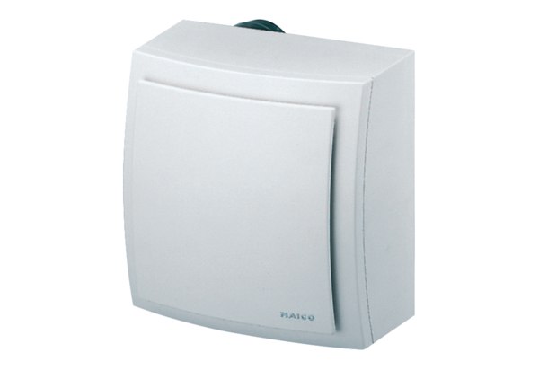Surface-mounted fan ER-AP 60 VZPacking unit: 1 pieceRange: B
Article number: 0084.0151Manufacturer: MAICO

