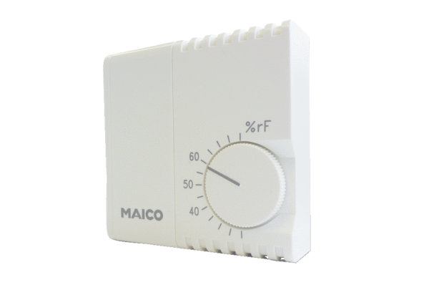Hygrostat HY 230Packing unit: 1 pieceRange: C
Article number: 0157.0126Manufacturer: MAICO

