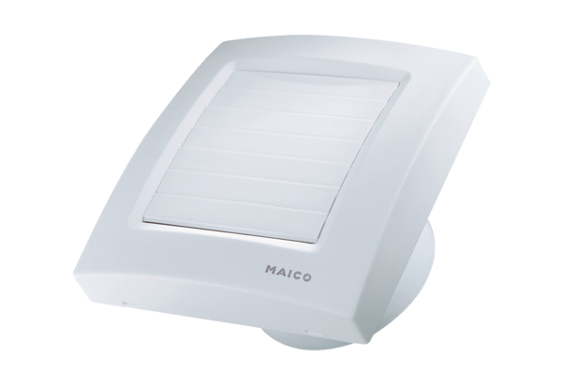Small room fan ECA 120 KPacking unit: 1 pieceRange: A
Article number: 0084.0009Manufacturer: MAICO

