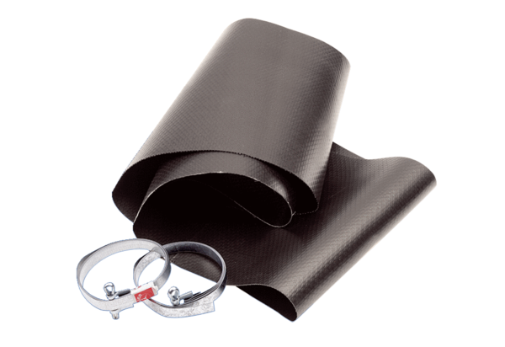Flexible cuff EL 40Packing unit: 1 pieceRange: C
Article number: 0092.0091Manufacturer: MAICO

