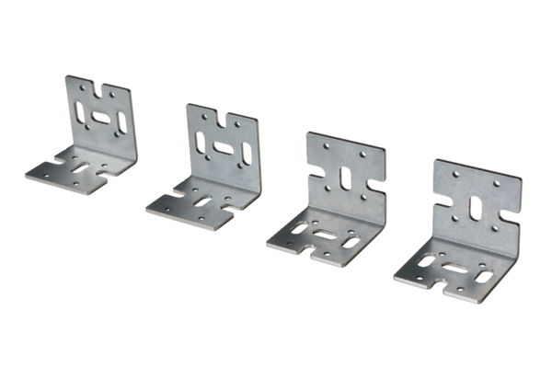Universal fixing bracket WS-BWU 160Packing unit: 4 piecesRange: K
Article number: 0092.0567Manufacturer: MAICO

