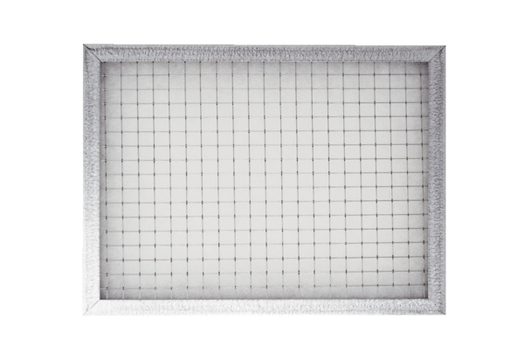Push-in frame for air filter WSG-ES 300Packing unit: 1 pieceRange: K
Article number: 0093.1326Manufacturer: MAICO

