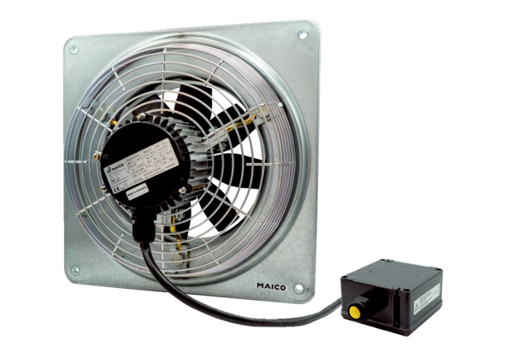Axial wall fan DZQ 30/4 B Ex ePacking unit: 1 pieceRange: C
Article number: 0083.0175Manufacturer: MAICO

