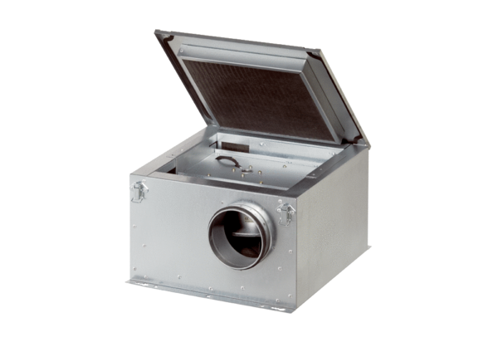Sound-insulated ventilation box ESR 25-2Packing unit: 1 pieceRange: C
Article number: 0080.0059Manufacturer: MAICO

