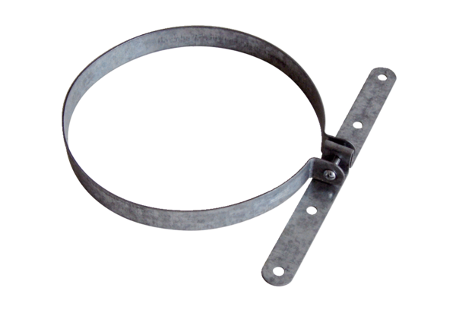Mounting clamp BS 125Packing unit: 1 pieceRange: B
Article number: 0092.0359Manufacturer: MAICO

