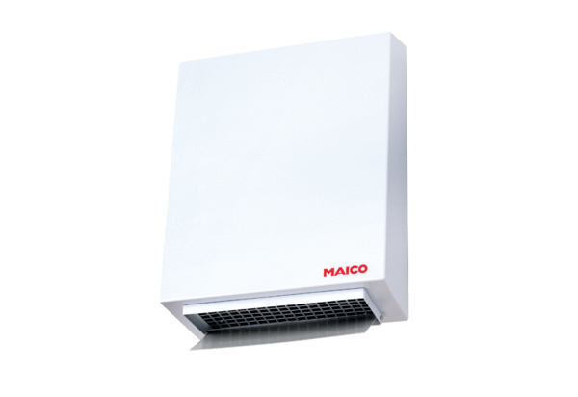Centrifugal external wall fan AWV 20 SPacking unit: 1 pieceRange: C
Article number: 0080.0999Manufacturer: MAICO

