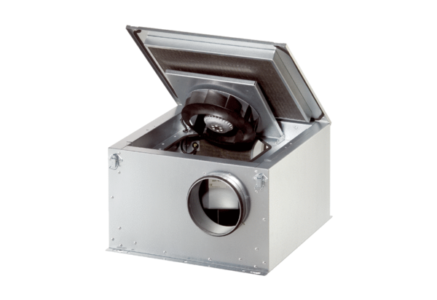Sound-insulated ventilation box DSR 35-2 SPacking unit: 1 pieceRange: C
Article number: 0080.0622Manufacturer: MAICO

