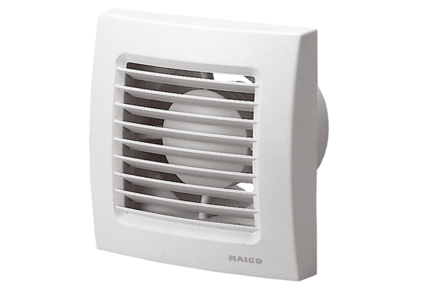Small room fan ECA 100 FPacking unit: 1 pieceRange: A
Article number: 0084.0002Manufacturer: MAICO

