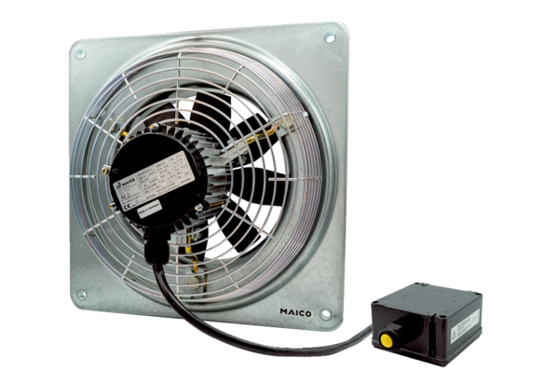Axial wall fan DZQ 25/4 B Ex ePacking unit: 1 pieceRange: C
Article number: 0083.0172Manufacturer: MAICO

