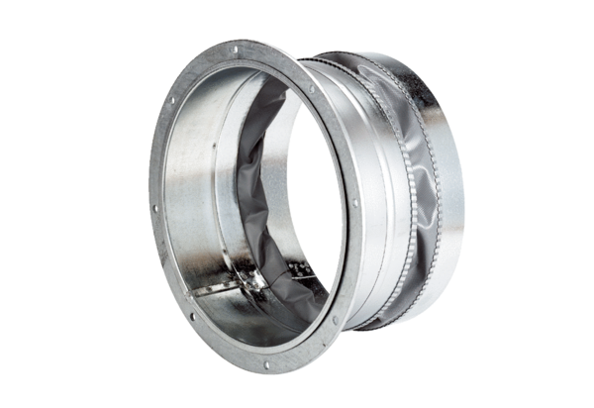Flexible coupling ELA 25Packing unit: 1 pieceRange: C
Article number: 0092.0266Manufacturer: MAICO

