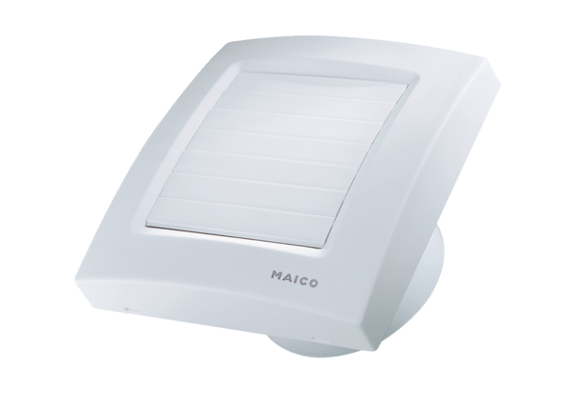Small room fan ECA 100 KPPacking unit: 1 pieceRange: A
Article number: 0084.0033Manufacturer: MAICO

