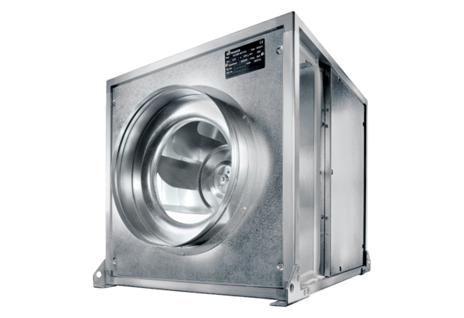Quickbox DSQ 45/4 KPacking unit: 1 pieceRange: C
Article number: 0080.0078Manufacturer: MAICO

