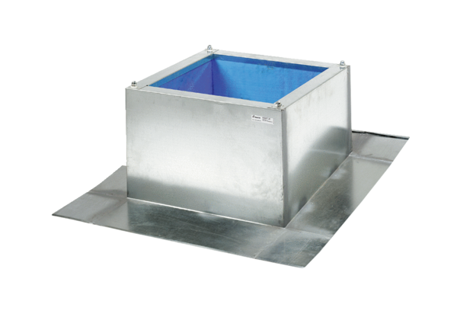Roof socket for corrugated and trapezoidal roofs SOWT 25Packing unit: 1 pieceRange: C
Article number: 0093.0985Manufacturer: MAICO

