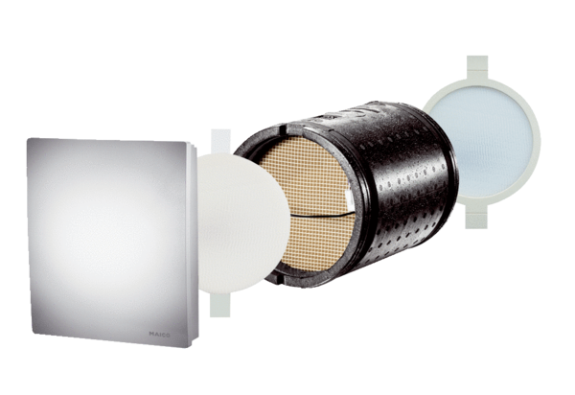Final assembly kit PP 60 K-SEPacking unit: 1 pieceRange: K
Article number: 0095.0204Manufacturer: MAICO

