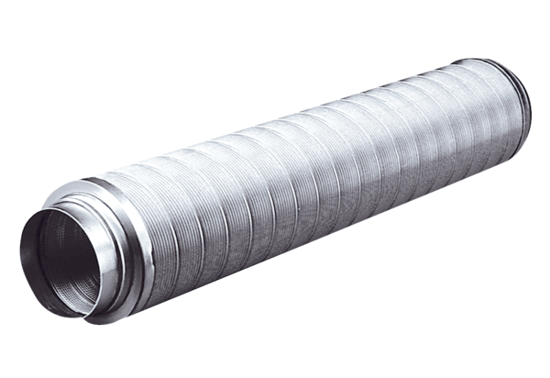Tubular sound absorber RSR 31Packing unit: 1 pieceRange: C
Article number: 0092.0319Manufacturer: MAICO

