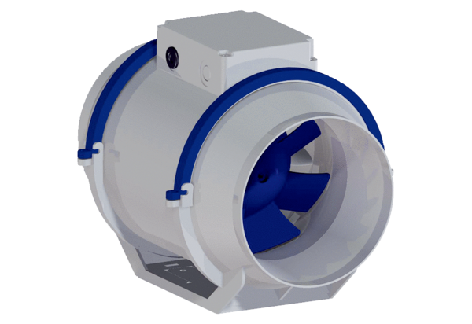Diagonal fan HDR 15 ECPacking unit: 1 pieceRange: E
Article number: 0080.0542Manufacturer: MAICO

