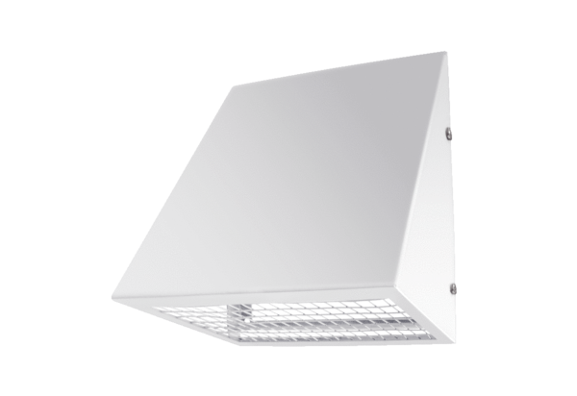Outside air wall connection KW-AL 16WPacking unit: 1 pieceRange: K
Article number: 0152.0078Manufacturer: MAICO

