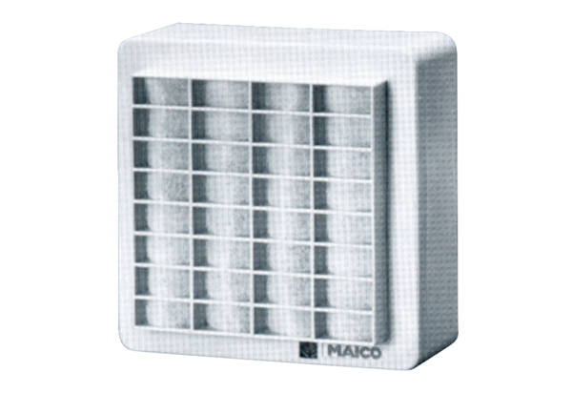Surface-mounted fan ERA 11Packing unit: 1 pieceRange:
Article number: 0080.0105Manufacturer: MAICO

